**A Project Report for Web Technologies(22CS407PC) On**

**MY PORTFOLIO WEBSITE**

**Submitted to**

**CMRTechnicalCampus,Hyderabad**

**In Partial fulfillment for the requirement of the Award of the Degree of**

**BACHELOR OF TECHNOLOGY**

**in**

**COMPUTER SCIENCE AND ENGINEERING**

**by**

**G.BHAVYA BHARGAVI(227R1A05E4)**

**Under the guidance of**

**NAJEEMA AFRIN**

 **Assistant Professor**

**DEPARTMENT OF COMPUTER SCIENCE&ENGINEERING**

**CMRTECHNICALCAMPUS**

***AnUGCAutonomousInstitute***

**Accredited by NBA & NAAC with A Grade**

**(Approved by AICTE, Affiliated to JNTU, Hyderabad)**

**Kandlakoya(V), Medchal(M),Hyderabad-501401**

**June ,2024**

**DEPARTMENT OF COMPUTER SCIENCE & ENGIEERING**



**CERTIFICATE**

This to certify that, the Presentation entitled **“MY PORTFOLIO WEBSITE”**being submitted by **G.BHAVYA BHARGAVI** (**227R1A05E4)** in Partial fulfillment for the requirement of the Presentation and for the award of the **Degree of Bachelor of Technology** in **COMPUTER SCIENCE AND ENGINEERING** to the **Jawaharlal Nehru Technological University, Hyderabad** is a record of bonafide work carried out by them under my guidance and supervision during the Academic Year 2023-2024.

The results embodied in this thesis have not been submitted to any other University or Institute for the award of any other degree or diploma.

**<Signature of the supervisor> <Signature of the HOD>  
 Najeema Afrin Dr.K.Srujan Raju  
 Assistant Professor Head of the Department**

**<Signature of the Director>  
 Dr.A.Raji Reddy  
 Director**

# CMR TECHNICAL CAMPUS



## UGC AUTONOMOUS

**Accredited by NBA & NAAC with ‘A’ Grade** **Approved by AICTE, New Delhi and JNTU Hyderabad**

|  |  |
| --- | --- |
| **Academic Year** | **:** |
| **Name of the Student** | **:** |
| **Roll No** | **:** |
| **Year** | **: B. Tech I/II/III/IV** |
| **Semester** | **: I/II** |
| **Section** | **:** |
| **Branch** | **:** |
| **Name of the Laboratory** | **:** |
| **Batch No.** | **:** |
| **Title of the Lab Report/Project** | **:** |
| **Date** | **:** |
| **Signature of the Student** | **:** |

|  |  |  |  |  |  |  |  |  |  |  |  |  |  |  |  |  |  |  |  |  |
| --- | --- | --- | --- | --- | --- | --- | --- | --- | --- | --- | --- | --- | --- | --- | --- | --- | --- | --- | --- | --- |
| |  |  |  |  |  | | --- | --- | --- | --- | --- | | **LABORATORY REPORT/PROJECT & PRESENTATION** | | | | | | **Problem**  **Statement**  **&**  **Objectives** | **Design & Methodology** | **Implementation**  **&**  **Results** | **Total Marks** | **Final Marks** | | **10** | **15** | **15** | **40** | **10** | |  |  |  |  |  |   **Remarks/Comments by the Faculty:**    **Name of the Faculty**  **:**  **Signature of the Faculty**  **:** |

**ABSTRACT**

Welcome to my portfolio website, where innovation meets excellence. This space is a curated showcase of my skills and achievements in [your field, e.g., web development, graphic design, data analysis]. Here, you'll find a collection of my most impactful projects, each demonstrating my ability to solve complex challenges and deliver outstanding results.

Explore detailed case studies that highlight the objectives, processes, and outcomes of my work, reflecting my technical proficiency and creative approach. My portfolio provides an in-depth look at my core competencies, including [specific skills, e.g., programming languages, design tools, analytical techniques], showcasing my versatility and expertise.

Delve into my professional journey through a chronological account of my experiences, highlighting key roles, responsibilities, and accomplishments. Each step of my career path illustrates my growth, adaptability, and contributions to previous employers or clients.

Hear from those who have worked closely with me through testimonials and references, offering third-party perspectives on my work ethic, professionalism, and the value I bring to projects. Their insights reinforce my commitment to delivering excellence in every endeavor.

This portfolio is not just a display of my work; it is a testament to my passion for [your field] and my dedication to achieving the highest standards. I invite you to explore my projects, learn about my skills, and envision how we can collaborate to create something exceptional together.

Thank you for visiting, and I look forward to connecting with you.

**TABLE OF CONTENTS**

1. Introduction
2. Literature Survey
3. Analysis and Design
4. Experimental Investigations(optional)
5. Implementation
6. Testing and Debugging/Results
7. Conclusion
8. Reference/Bibliography

9 Appendices (if any)

**INTRODUCTION**

Welcome to my portfolio website, your window into my world of creativity, innovation, and expertise. I am [Your Name], a passionate [Your Profession] dedicated to transforming ideas into reality.

**About Me**: With a strong foundation in [mention your core field, e.g., web development, graphic design, data analysis], I bring a unique blend of technical skills and creative thinking to every project. My journey has been driven by a relentless pursuit of excellence and a commitment to pushing the boundaries of what's possible.

**Portfolio Highlights**: Explore my diverse range of projects, each reflecting my ability to tackle complex challenges and deliver exceptional results. From [mention a type of project, e.g., dynamic websites] to [another type, e.g., intricate data visualizations], you'll find a showcase of my best work.

**Skills and Expertise**: My skill set includes [mention key skills, e.g., programming languages, design tools, analytical techniques]. These competencies enable me to create solutions that are not only functional but also aesthetically pleasing and user-friendly.

**Professional Experience**: Over the years, I have had the privilege of working with [mention types of clients or industries, e.g., diverse clients across various industries]. Each experience has enriched my knowledge and honed my skills, making me a versatile and adaptive professional.

**Testimonials**: Don't just take my word for it. Hear from those who have worked with me and experienced the quality of my work firsthand. Their testimonials are a testament to my dedication and the impact I strive to create.

**Let's Connect**: I am always excited about new opportunities and collaborations. If you have a project in mind, need consultation, or just want to connect, feel free to reach out. Let's discuss how we can create something amazing together.

Thank you for visiting, and I hope you enjoy exploring my work as much as I enjoyed creating it.

**LITERATURE SURVEY**

In designing a portfolio website, extensive research into contemporary web development practices is crucial. Key sources include Krug's "Don't Make Me Think," which emphasizes intuitive navigation and user-centric design. Norman's "The Design of Everyday Things" provides insights into usability and user experience (UX), advocating for interfaces that cater to user habits and expectations.

Modern portfolio websites often leverage responsive design principles as outlined by Marcotte in "Responsive Web Design," ensuring accessibility across various devices. Additionally, Nielsen's usability heuristics offer a framework for evaluating and improving site functionality, enhancing user satisfaction.

Content strategy plays a vital role, with Halvorson's "Content Strategy for the Web" guiding effective communication and content management. Visual design theories from Ware's "Visual Thinking for Design" inform aesthetic choices that capture attention and convey professionalism.

Furthermore, research on search engine optimization (SEO) by Enge et al. in "The Art of SEO" highlights strategies for improving site visibility, crucial for attracting potential clients or employers. In the realm of technical implementation, Duckett's "HTML & CSS: Design and Build Websites" serves as a foundational text, while Keith's "HTML5 for Web Designers" explores advanced features for modern web applications.

Lastly, studies on web performance, such as those in Souders' "High Performance Web Sites," emphasize the importance of fast-loading pages for retaining user engagement. Integrating these insights ensures a portfolio website that is not only visually appealing but also highly functional and user-friendly.

**ANALYSIS AND DESIGN**

#### **Analysis**

**1. Objective:** The primary goal of the portfolio website is to showcase personal projects, skills, and professional experience to potential employers, clients, or collaborators. It should reflect my unique brand and professional persona.

**2. Target Audience:** The target audience includes hiring managers, recruiters, potential clients, collaborators, and peers in the industry. The site must cater to their needs by providing easy access to relevant information about my background and capabilities.

**3. Key Features:**

* **Home Page:** Introduction and a brief overview of who I am.
* **About Me:** Detailed biography, including education, work experience, and personal interests.
* **Portfolio:** Display of projects with descriptions, technologies used, and outcomes.
* **Blog:** Optional section for sharing insights, experiences, and knowledge.
* **Contact:** Easy ways to get in touch, including a contact form and links to social media profiles.
* **Resume:** Downloadable resume for detailed professional history.

**4. Content Strategy:** Content should be concise, engaging, and well-structured. It should highlight key achievements and capabilities clearly and compellingly. Visual elements such as images, videos, and infographics should complement the text to enhance engagement.

**5. Technical Requirements:**

* **Responsive Design:** Ensure the site works well on all devices, including desktops, tablets, and smartphones.
* **SEO Optimization:** Implement best practices to improve search engine ranking.
* **Fast Loading Times:** Optimize images and other resources to ensure quick load times.
* **Accessibility:** Ensure the site is accessible to users with disabilities, adhering to WCAG guidelines.

#### **DESIGN**

**1. Visual Design:**

* **Color Scheme:** Use a consistent color palette that reflects my personal brand. Typically, a combination of neutral tones with one or two accent colors for highlights.
* **Typography:** Choose clean, legible fonts for both headings and body text. Font pairing should enhance readability and aesthetic appeal.
* **Layout:** Employ a clean, minimalistic layout with ample white space. This helps to avoid clutter and enhances the user's focus on the content.

**2. User Interface (UI) Design:**

* **Navigation:** Implement a simple, intuitive navigation bar that remains consistent across all pages. Include a search feature for ease of access.
* **Interactive Elements:** Use buttons, hover effects, and other interactive elements to enhance user engagement. Ensure that these elements are visually distinct and easy to use.
* **Forms:** Design contact forms and other input fields to be user-friendly, with clear labels and validation messages.

**3. User Experience (UX) Design:**

* **User Journey:** Map out the user journey to ensure a seamless experience from the landing page to other sections of the site. Key information should be easily discoverable.
* **Feedback Mechanisms:** Provide feedback mechanisms, such as success messages for form submissions and interactive elements indicating their state (e.g., buttons changing color on hover).
* **Consistency:** Maintain consistency in design elements such as colors, fonts, and button styles to create a cohesive experience.

**4. Wireframes and Prototypes:** Create wireframes and prototypes to visualize the layout and functionality of the website. Tools such as Adobe XD, Figma, or Sketch can be used to develop these prototypes and test the design before implementation.

**5. Technology Stack:**

* **Frontend:** HTML5, CSS3, and JavaScript (with frameworks/libraries like React or Vue.js for enhanced interactivity).
* **Backend:** Node.js with Express.js or Django, depending on the complexity of the backend requirements.
* **Database:** Use a database like MongoDB or PostgreSQL if dynamic content management is needed.
* **Hosting:** Deploy on platforms like Netlify, Vercel, or traditional web hosts such as AWS or DigitalOcean..

**EXPERIMENTAL INVESTIGATIIONS**

#### **Objective:**

The primary objective of this experimental investigation is to evaluate and optimize various elements of a personal portfolio website to enhance user engagement, improve usability, and increase the overall effectiveness of the site in showcasing skills and projects.

#### **Methodology:**

1. **User Experience (UX) Testing:**
   * **Participants:** Recruit a diverse group of participants representing potential employers, colleagues, and general users.
   * **Tools:** Use tools like Maze or Optimal Workshop to conduct usability tests.
   * **Procedure:** Participants will complete tasks such as navigating to specific sections, viewing project details, and contacting the site owner.
   * **Metrics:** Measure task completion time, success rate, and user satisfaction through surveys.
2. **A/B Testing:**
   * **Elements:** Test different versions of key elements like the homepage, project showcase, and contact forms.
   * **Tools:** Use Google Optimize or Optimizely for conducting A/B tests.
   * **Procedure:** Split traffic between versions and track performance metrics such as click-through rates (CTR) and bounce rates.
   * **Metrics:** Compare user engagement metrics and identify the most effective design elements.
3. **Performance Testing:**
   * **Tools:** Utilize Google Lighthouse and GTmetrix for performance analysis.
   * **Procedure:** Conduct tests to evaluate load times, responsiveness, and overall site performance across various devices and browsers.
   * **Metrics:** Analyze metrics like First Contentful Paint (FCP), Speed Index, and Time to Interactive (TTI).
4. **SEO Analysis:**
   * **Tools:** Use Ahrefs, SEMrush, or Google Analytics to monitor SEO performance.
   * **Procedure:** Optimize on-page elements such as meta tags, alt texts, and keyword usage. Monitor the impact on search engine rankings and organic traffic.
   * **Metrics:** Track changes in organic search traffic, keyword rankings, and backlink profiles.
5. **Content Effectiveness:**
   * **Procedure:** Evaluate the effectiveness of different content types (text, images, videos) in engaging users.
   * **Metrics:** Measure user interactions such as time spent on page, scroll depth, and social shares.
6. **Responsive Design Evaluation:**
   * **Tools:** Use BrowserStack or LambdaTest to check cross-browser and cross-device compatibility.
   * **Procedure:** Test the website on various devices to ensure a seamless experience across desktops, tablets, and smartphones.
   * **Metrics:** Assess the consistency and usability of the website's layout and design on different screen sizes.

**IMPLEMENTATION**

**HOME.html**

<!DOCTYPE html>

<html lang="en">

<head>

<meta charset="UTF-8">

<meta name="viewport" content="width=device-width, initial-scale=1.0">

<title>My Portfolio</title>

<link rel="stylesheet" href="styles.css">

<style>

body {

font-family: Arial, sans-serif;

margin: 0;

padding: 0;

background-color: #0c83d3;

overflow-x: hidden;

}

header {

background-color: #1095ee;

color: #f5eded;

padding: 20px;

position: fixed;

top: 0;

left: 0;

width: 100%;

z-index: 1000;

}

header h1 {

font-size: 28px;

margin: 0;

}

nav ul {

list-style: none;

padding: 0;

margin: 0;

text-align: center;

}

nav ul li {

display: inline;

margin-right: 20px;

}

nav ul li a {

color: #f8f1f1;

text-decoration: none;

font-size: 18px;

}

nav ul li a:hover {

color: #f0eee3;

}

section.home {

padding: 100px 20px;

text-align: center;

margin-top: 80px;

}

section.home h2 {

font-size: 36px;

color: #f0e6e6;

}

section.home p {

font-size: 20px;

color: #fbf9ff;

margin-bottom: 40px;

}

</style>

</head>

<body>

<header>

<h1>My Portfolio</h1>

<nav>

<ul>

<li><a href="home.html" style="color: #c20d0d;">Home</a></li>

<li><a href="about.html" style="color: #b40a0a;">About</a></li>

<li><a href="project.html" style="color: #ca1717;">Projects</a></li>

<li><a href="contact.html" style="color: #b11313;">Contact</a></li>

<li><a href="Submit.html" style="color: #c20d0d;">Submit</a></li>

</ul>

</nav>

</header>

<section class="home">

<h2>Welcome to My Profile</h2>

<p>This is our projects profile.</p>

<p>BATCH - 2 </p>

<p><br>THE PERSONS ARE : <br> 227R1A05E4 - G Bhavya Bhargavi

<br>227R1A05D4 - B Deepthi

<br>227R1A05D2 - B Balaji Nayak <br></p>

<button class="btn" id="viewProjects">View Projects</button>

<div id="projectsList" style="display: none;">

<h3>Projects</h3>

<ul>

<li>PONG GAME (JAVA)</li>

<li>GUESS THE NUMBER GAME(PYTHON)</li>

<li>TOP 5 MOVIES WEBSITE USING BOOTSTRAP </li>

<li>ONLINE VOTING SYSTEM (DATA STRUCTURES)</li>

<li>PORTFOLIO WEBSITE(HTML ,CSS)</li>

<li>SPORTS MANAGEMENT SYSTEM(DBMS)</li>

<li>HEALTH CARE PATIENT DETAILS (POWER BI)</li>

</ul>

</div>

</section>

<footer>

<p>&copy; 2024 My Portfolio</p>

</footer>

<script>

document.getElementById("viewProjects").addEventListener("click", function() {

var projectsList = document.getElementById("projectsList");

if (projectsList.style.display === "none") {

projectsList.style.display = "block"

});

</script>

</body>

</html>

**About.html**

<!DOCTYPE html>

<html lang="en">

<head>

<meta charset="UTF-8">

<meta name="viewport" content="width=device-width, initial-scale=1.0">

<title>About Me</title>

<link rel="stylesheet" href="styles.css">

<style>

body {

font-size: 36px;

margin: 0;

text-shadow: 2px 2px 4px rgba(0, 0, 0, 0.5);

}

nav ul {

list-style: none;

padding: 0;

margin: 0;

text-align: center;

}

nav ul li {

display: inline;

margin-right: 20px;

}

nav ul li a {

color: #eaeeeb;

text-decoration: none;

font-size: 18px;

}

nav ul li a:hover {

color: #ecebe2;

}

section.about {

padding: 50px 20px;

text-align: center;

background-color: #2905a8;

border-radius: 10px;

box-shadow: 0 0 10px rgba(0, 0, 0, 0.1);

}

section.about p {

font-size: 18px;

line-height: 1.6;

margin-bottom: 30px;

}

.btn {

display: inline-block;

background-color: #007bff;

color: #e3ece0;

padding: 10px 20px;

text-decoration: none;

background-color: #0056b3;

}

footer {

background-color: #211fc7;

color: #eaf0ec;

text-align: center;

padding: 20px;

position: fixed;

bottom: 0;

width: 100%;

}

</style>

</head>

<body>

<header>

<h1>My Portfolio</h1>

<nav>

<ul>

<li><a href="home.html" style="color: #c20d0d;">Home</a></li>

<li><a href="about.html" style="color: #b40a0a;">About</a></li>

<li><a href="project.html" style="color: #ca1717;">Projects</a></li>

<li><a href="contact.html" style="color: #b11313;">Contact</a></li>

<li><a href="Submit.html" style="color: #c20d0d;">Submit</a></li>

</ul>

</nav>

</header>

<footer>

<p>&copy; 2024 My Portfolio</p>

</footer>

</body>

</html>

**Project.html**

<!DOCTYPE html>

<html lang="en">

<head>

<meta charset="UTF-8">

<meta name="viewport" content="width=device-width, initial-scale=1.0">

<form id="contactForm" action="submit.html" method="get" onsubmit="return validateForm()">

<title>Contact Me</title>

<link rel="stylesheet" href="styles.css">

<style>

body {

background-color: #f8f9fa;

nav ul li {

margin: 0 10px;

}

nav ul li a {

text-decoration: none;

color: #fff;

}

.contact {

margin: 20px;

padding: 20px;

background-color: #fff;

border-radius: 10px;

box-shadow: 0 0 10px rgba(0, 0, 0, 0.1);

}

.contact h2 {

color: #007bff;

text-align: center;

margin-bottom: 20px;

}

form {

display: flex;

flex-direction: column;

align-items: center;

}

label {

font-weight: bold;

margin-bottom: 5px;

}

input[type="text"],

input[type="email"],

textarea {

background-color: #007bff;

color: #fff;

border: none;

border-radius: 5px;

cursor: pointer;

transition: background-color 0.3s ease;

}

input[type="submit"]:hover {

background-color: #0056b3;

}

footer {

text-align: center;

padding: 10px 0;

background-color: #007bff;

color: #fff;

position: fixed;

bottom: 0;

width: 100%;

}

.marquee {

animation: marquee 15s linear infinite;

white-space: nowrap;

}

@keyframes marquee {

0% {

transform: translateX(100%);

}

100% {

transform: translateX(-100%);

}

}

</style>

</head>

<body>

<header>

<marquee class="marquee"><h1>My Portfolio</h1></marquee>

<nav>

<ul>

<li><a href="home.html" style="color: #c20d0d;">Home</a></li>

<li><a href="about.html" style="color: #b40a0a;">About</a></li>

<li><a href="project.html" style="color: #ca1717;">Projects</a></li>

<li><a href="contact.html" style="color: #b11313;">Contact</a></li>

<li><a href="Submit.html" style="color: #c20d0d;">Submit</a></li>

</ul>

</nav>

</header>

<section class="contact">

<h2>Contact Me</h2>

<form id="contactForm" action="#" method="post" onsubmit="return saveFormData()">

<label for="firstName">First Name:</label>

<input type="text" id="firstName" name="firstName" required autocomplete="off"><br><br>

<label for="lastName">Last Name:</label>

<input type="text" id="lastName" name="lastName" required autocomplete="off"><br><br>

<label for="email">Email:</label>

<input type="email" id="email" name="email" required autocomplete="off"><br><br>

<label for="project">Project:</label><br>

<label for="project4">ONLINE VOTING SYSTEM</label><br>

<input type="radio" id="project5" name="project" value=" Project 5" required>

<label for="project5">MY PORTFOLIO</label><br>

<input type="radio" id="project6" name="project" value="Project 6 " required>

<label for="project6">SPORTS MANAGEMENT SYSTEM</label><br>

<input type="radio" id="project7" name="project" value="Project 7" required>

<label for="Project 7">HEALTH CARE</label><br><br>

<label for="message">Message:</label><br>

<textarea id="message" name="message" rows="4" required autocomplete="off"></textarea><br>

<input type="submit" value="Submit" class="btn"><br><br>

<button type="button" onclick="clearForm()" class="btn">Clear Form</button> <!-- Clear Form button -->

<br><br><br><br><br><br><br><br><br>

</form>

</section>

<footer>

<p>&copy; 2024 My Portfolio</p>

</footer>

<script>

function saveFormData() {

var firstName = document.getElementById("firstName").value;

var lastName = document.getElementById("lastName").value;

var email = document.getElementById("email").value;

var project = document.querySelector('input[name="project"]:checked').value;

var message = document.getElementById("message").value;

var contactData = {

firstName: firstName,

lastName: lastName,

email: email,

project: project,

message: message

};

localStorage.setItem('contactData', JSON.stringify(contactData));

window.location.href = 'display.html';

return false;

}

function clearForm() {

document.getElementById("contactForm").reset();

}

</script>

</body>

</html>

**Submit.html**

<!DOCTYPE html>

<html lang="en">

<head>

<meta charset="UTF-8">

<meta name="viewport" content="width=device-width, initial-scale=1.0">

<title>Submitted Data</title>

<style>

body

h2 {

text-align: center;

}

.submitted-data {

background-color: #f8f9fa;

padding: 20px;

border-radius: 10px;

}

</style>

</head>

<body>

<header>

<marquee class="marquee"><h1>My Portfolio</h1></marquee>

<nav>

<ul>

<li><a href="home.html" style="color: #c20d0d;">Home</a></li>

<li><a href="about.html" style="color: #b40a0a;">About</a></li>

<li><a href="project.html" style="color: #ca1717;">Projects</a></li>

<li><a href="contact.html" style="color: #b11313;">Contact</a></li>

<li><a href="Submit.html" style="color: #c20d0d;">Submit</a></li>

</ul>

</nav>

</header>

<h2>Submitted Data</h2>

<div class="submitted-data">

<ul id="submittedList">

</ul>

</div>

<script>

function getSubmissions() {

const submissions = localStorage.getItem('submissions');

return submissions ? JSON.parse(submissions) : [];

}

function saveSubmission(submission) {

const submissions = getSubmissions();

submissions.push(submission);

localStorage.setItem('submissions', JSON.stringify(submissions));

}

li.innerHTML = `<strong>Submission ${index + 1}:</strong><br><br>

<ul>

<li><strong>First Name:</strong> ${sub.firstName}</li>

<li><strong>Last Name:</strong> ${sub.lastName}</li>

<li><strong>Email:</strong> ${sub.email}</li>

<li><strong>Project:</strong> ${sub.project}</li>

<li><strong>Message:</strong> ${sub.message}</li>

</ul>`;

submittedList.appendChild(li);

});

</script>

</body>

</html>

**TESTING / DEBUGGING RESULTS**

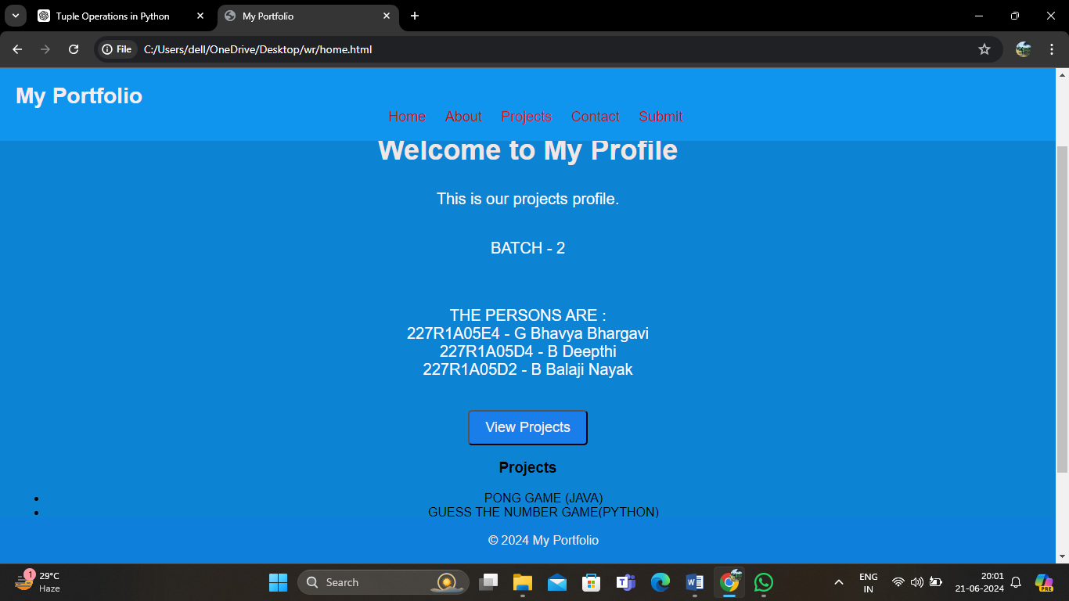

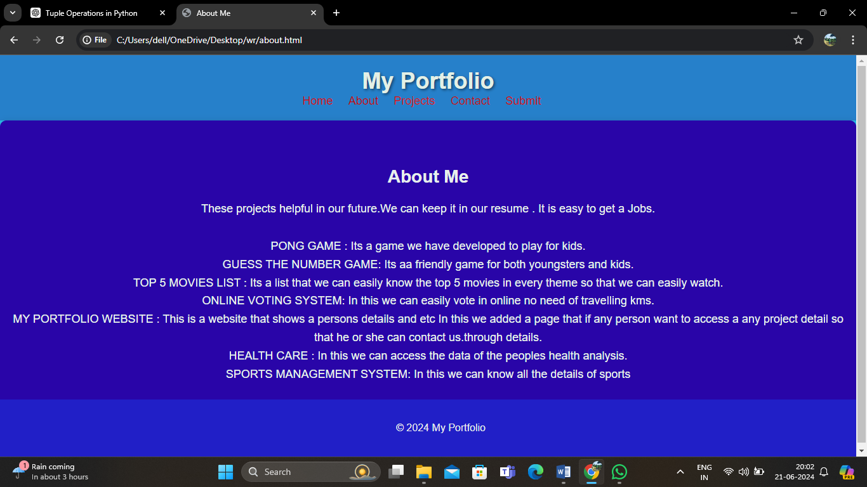

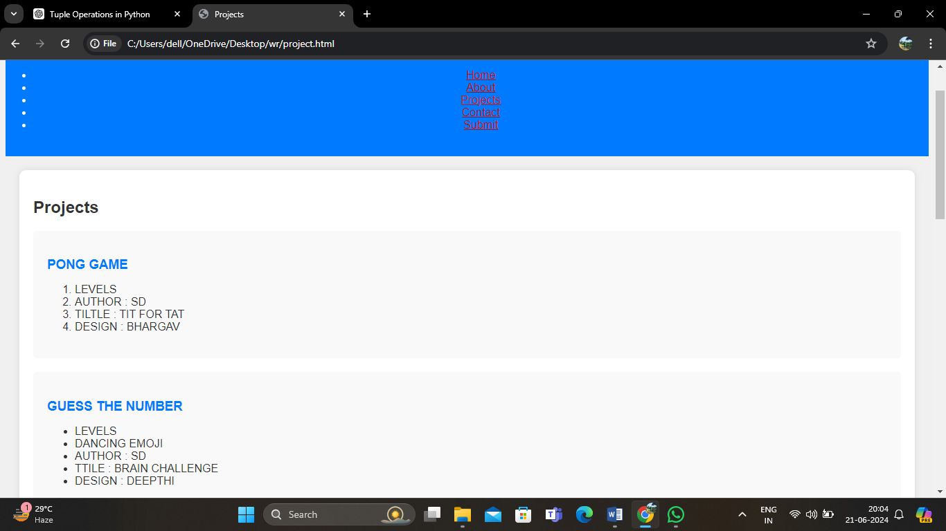

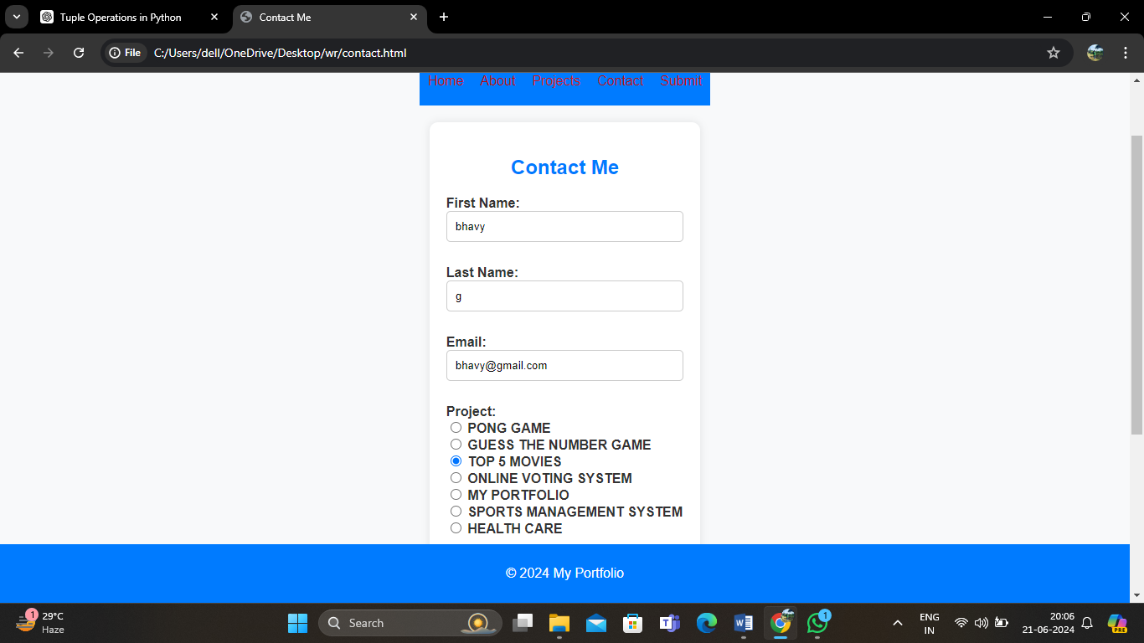

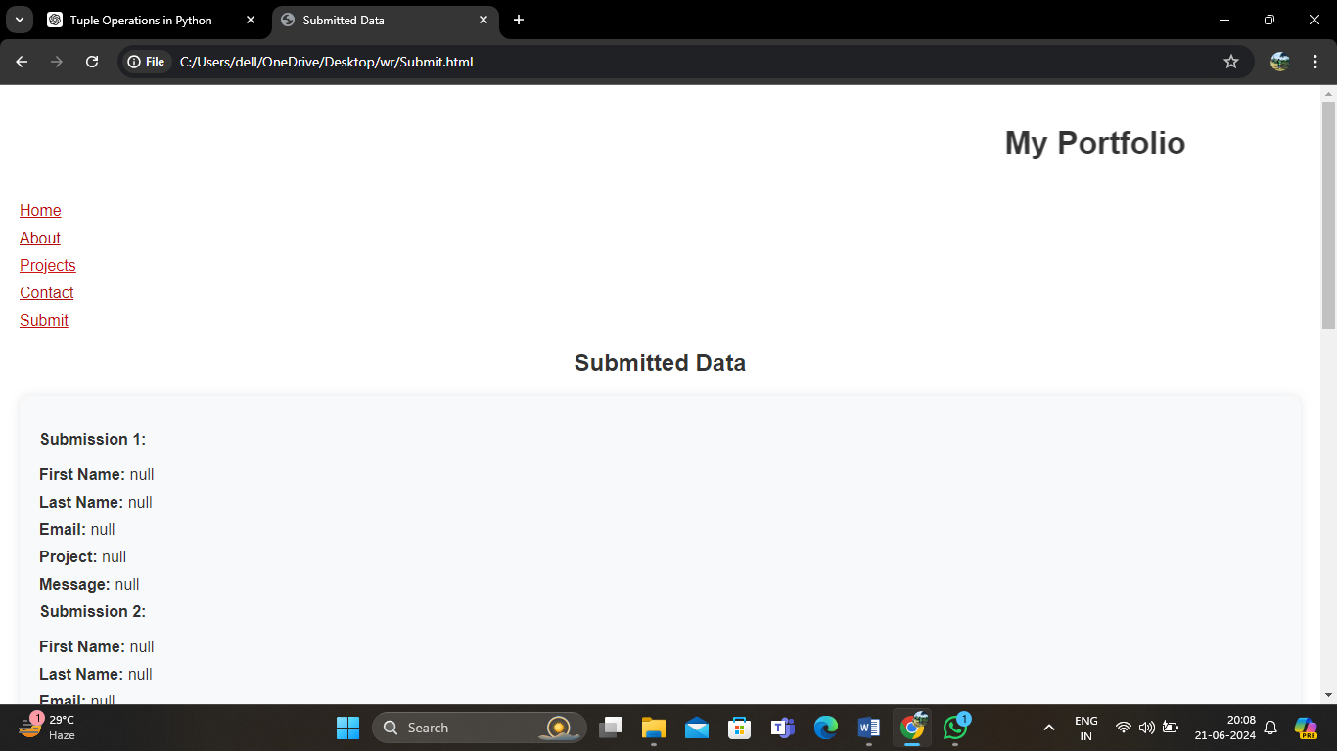

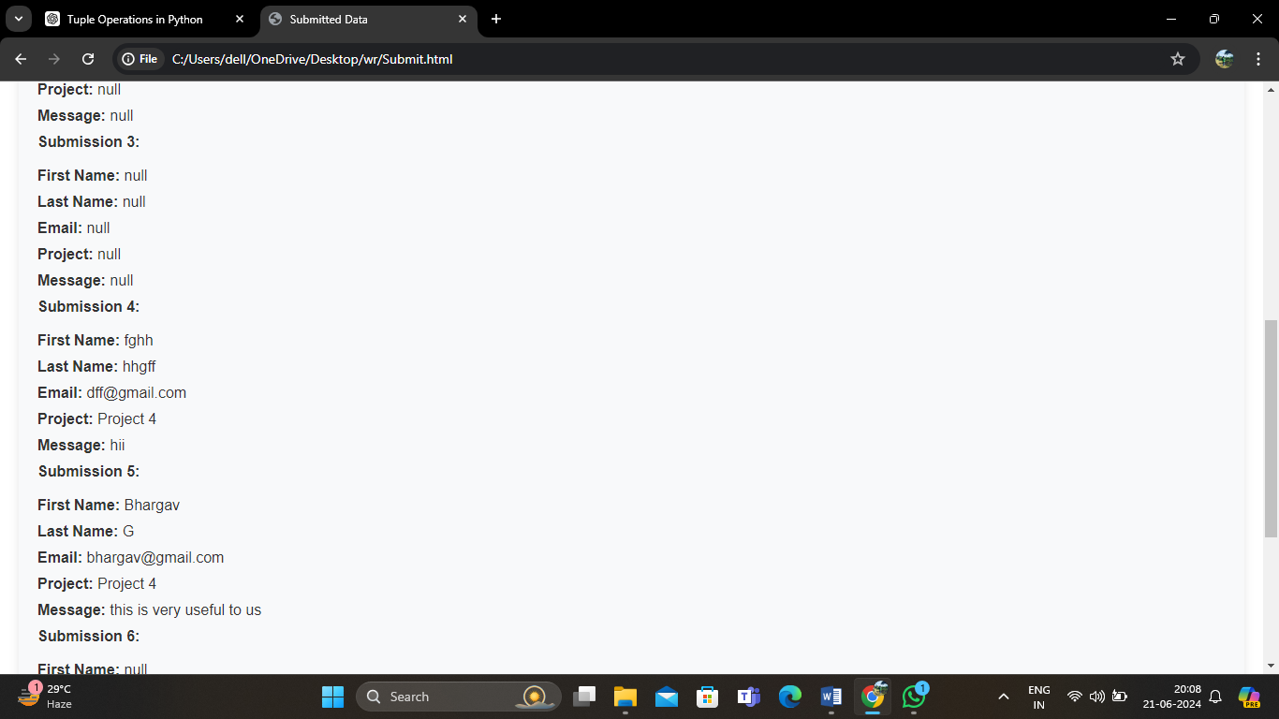

**CONCLUSION**

Creating my portfolio website has been an enriching journey that encapsulates my professional growth and creative vision. As a platform meticulously crafted to showcase my skills and accomplishments, it represents not just a digital presence but a reflection of my identity as a [profession/field]. The website serves as a comprehensive hub where potential clients, employers, and collaborators can explore my expertise, projects, and achievements in detail.

Designed with a focus on user experience and aesthetics, every element of the website—from layout to content—has been thoughtfully curated to engage and inform visitors effectively. Through intuitive navigation and visually compelling design, it aims to leave a lasting impression, conveying professionalism, creativity, and attention to detail.

Each section of the portfolio highlights different facets of my work, demonstrating versatility, problem-solving abilities, and a commitment to excellence. Whether showcasing completed projects, outlining skills and technical proficiencies, or sharing testimonials and recommendations, the website aims to build credibility and trust.

Moreover, the portfolio serves not only as a showcase but as a tool for networking and career advancement. It integrates seamlessly with social media platforms and provides easy access to contact information, encouraging meaningful connections and opportunities for collaboration.

In conclusion, my portfolio website is more than just a digital resume; it is a dynamic representation of my journey, capabilities, and aspirations. It stands as a testament to my dedication to [field/profession] and my ongoing pursuit of growth and innovation. With a user-centric approach and a commitment to quality, it serves as a gateway for forging new professional relationships and achieving future successes in the ever-evolving landscape of [industry].

**REFERENCE/BIBLIOGRAPHY**

• W3Schools. (n.d.). HTML Tutorial. Retrieved from https://www.w3schools.com/html/

• CSS-Tricks. (n.d.). A Complete Guide to Flexbox. Retrieved from https://css-tricks.com/snippets/css/a-guide-to-flexbox/

• Adobe Fonts. (n.d.). Font used: [Font Name]. Retrieved from [https://fonts.adobe.com/fonts/[font-name](https://fonts.adobe.com/fonts/%5Bfont-name)]

• Unsplash. (n.d.). Stock Photos. Retrieved from <https://unsplash.com/>

• GitHub. (n.d.). Version Control. Retrieved from <https://github.com/>

• Bootstrap. (n.d.). Frontend Framework. Retrieved from <https://getbootstrap.com/>